**Nhóm 5**

Thành viên nhóm

2011068837 Phạm Thế Hùng

2011060017 Lê Tuấn Anh

2011068613 Nguyễn Văn Cường

2011069006 Lê Chí Phong

2011069010 Trần Thiên Phúc

Get All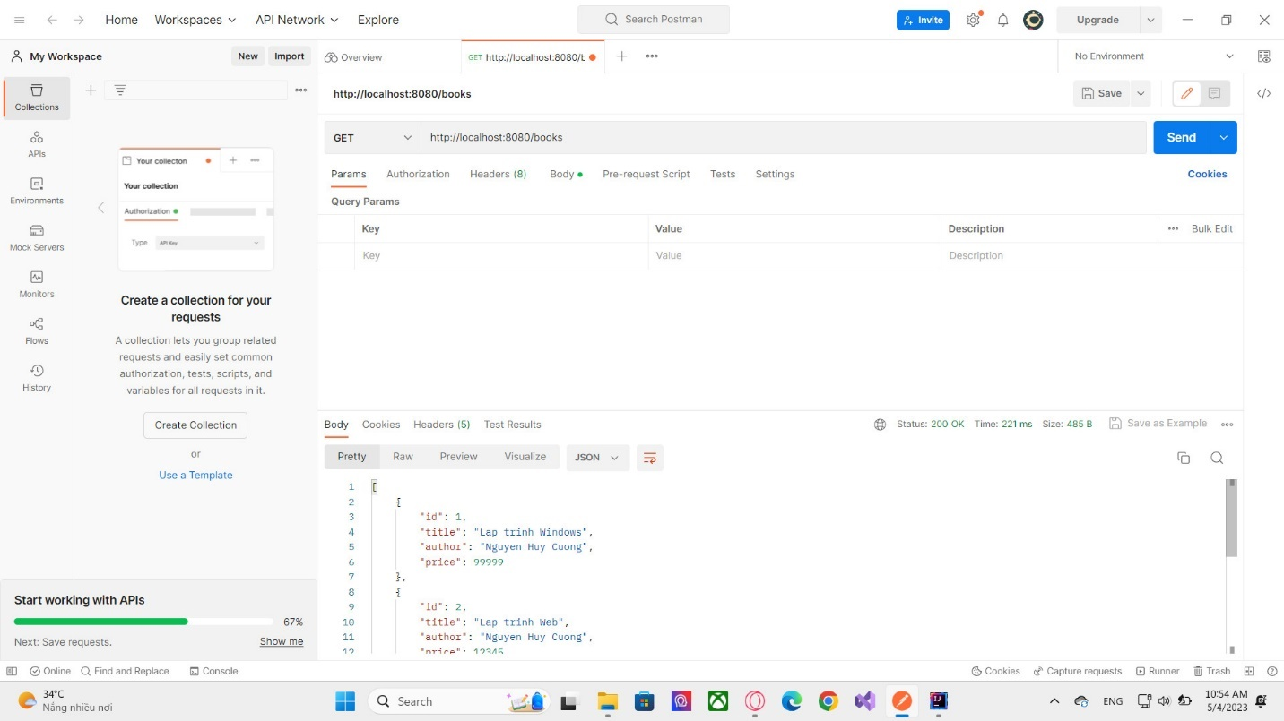

Get Id

Create

Sau khi tạo

Delete

Sau khi xóa

Tìm kiếm

